New Hampshire
ARIMA (0,1,5) (0,1,1)
Parameter | Estimate | Std. Error | t-statistic | p-value
θ₁ | -1.004 | 0.05376 | -18.67 | <.0001
θ₂ | 0.134 | 0.07496 | 1.79 | 0.0737
θ₃ | 0.361 | 0.07493 | 4.82 | <.0001
θ₄ | -0.315 | 0.07704 | -4.09 | <.0001
θ₅ | 0.085 | 0.05398 | 1.58 | 0.1134
Θ₁ | -0.744 | 0.04024 | 18.49 | <.0001
β | 0.299 | 0.07937 | 3.77 | 0.0002
ω₁ | 0.092 | 0.04756 | 1.94 | 0.0522

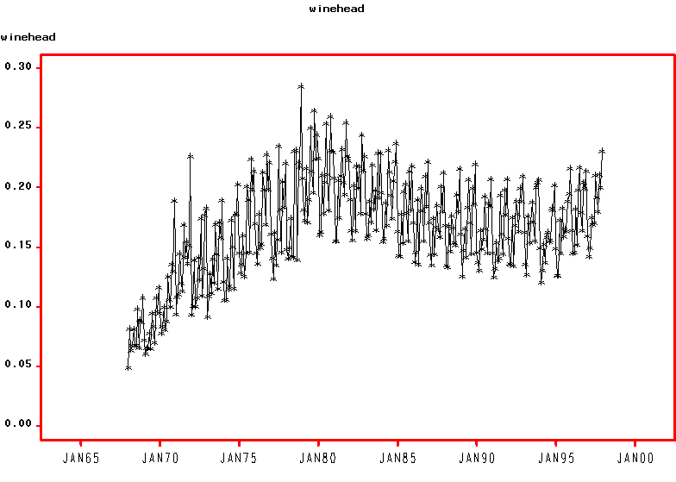

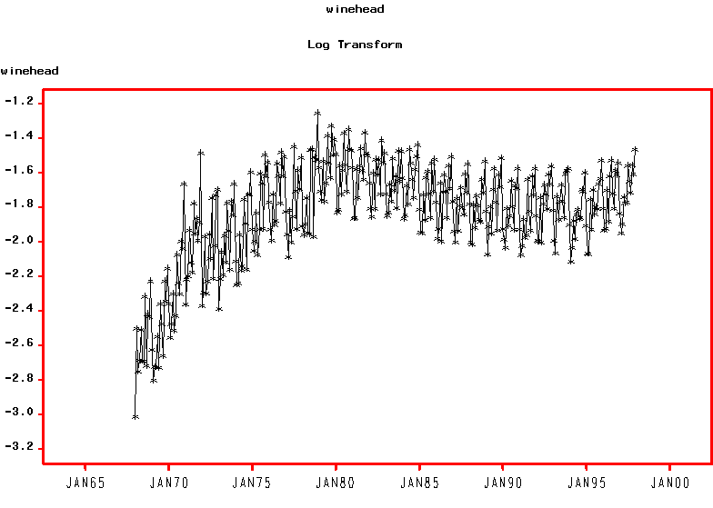
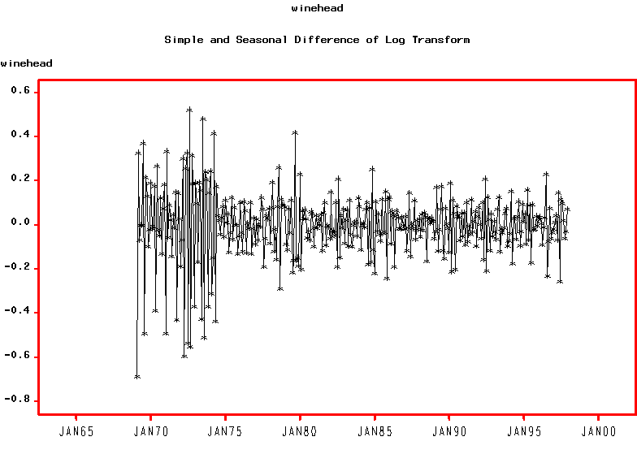
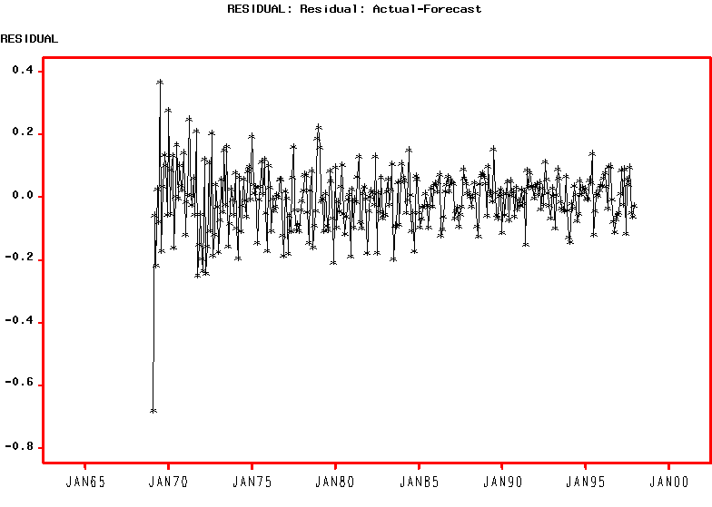
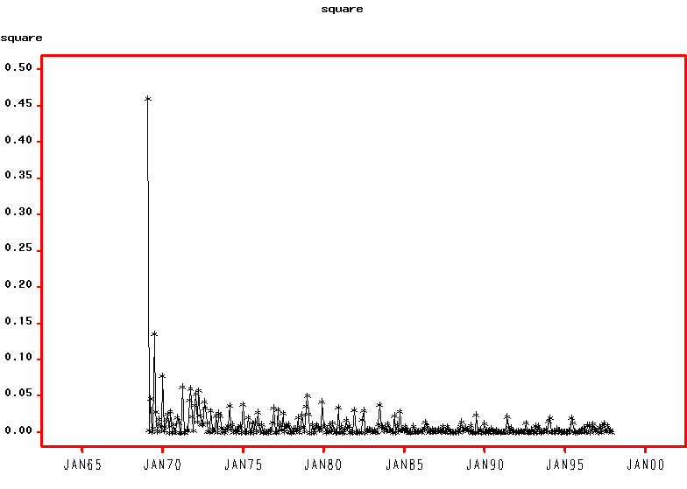

GARCH (1,1)

Value Std.Error t value Pr(>|t|)
MA(1) -0.81689099 0.04396007 -18.58257 0.0000000
MA(2) -0.00193527 0.05771593 -0.03353 0.4866355
MA(3) 0.07260846 0.04723762 1.53709 0.0626049
MA(4) 0.00000000 NA NA NA
MA(5) 0.00000000 NA NA NA
MA(6) 0.00000000 NA NA NA
MA(7) 0.00000000 NA NA NA
MA(8) 0.00000000 NA NA NA
MA(9) 0.00000000 NA NA NA
MA(10) 0.00000000 NA NA NA
MA(11) 0.00000000 NA NA NA
MA(12) -0.55838840 0.03694113 -15.11563 0.0000000
MA(13) 0.42260902 0.04101714 10.30323 0.0000000
xwine.s1 0.12796499 0.03567777 3.58669 0.0001922
xwine.ctrl 0.22635871 0.06357553 3.56047 0.0002117
A 0.00006115 0.00003716 1.64572 0.0503764
ARCH(1) 0.01608049 0.01580409 1.01749 0.1548253
GARCH(1) 0.96735657 0.01970776 49.08505 0.0000000

--------------------------------------------------------------

AIC(18) = -683.3737
BIC(18) = -614.0859

Normality Test:
--------------------------------------------------------------
Jarque-Bera P-value Shapiro-Wilk P-value
9.341 0.009368 0.9881 0.8476

Ljung-Box test for standardized residuals:
--------------------------------------------------------------
Statistic P-value Chi^2-d.f.
15.93 0.1945 12

Ljung-Box test for squared standardized residuals:
--------------------------------------------------------------
Statistic P-value Chi^2-d.f.
10.97 0.5318 12

